Homework Assignment #1

1. Matlab code:

% for homework 1

% problem 1

clear; close all;

PI = [0.2 0.2 0.5 0.1; 0.2 0.3 0.4 0.1; 0.4 0.2 0.3 0.1; 0.1 0 0 0.9]; % transition matrix

M = 3; % number of chains

N = 4; % number of states

K = 200; % number of time steps in each chain

for m = 1:M

x(1,m) = ceil(N\*rand); % random initial

for k = 2:K

% generate a chain

P = PI(x(k-1,m),:); %pick i-th row

U = rand;

if U < P(1)

x(k,m) = 1;

elseif (P(1)<U&&U<P(1)+P(2))

x(k,m) = 2;

elseif(P(1)+P(2)<U&&U<P(1)+P(2)+P(3))

x(k,m) = 3;

else

x(k,m) = N;

end

end

end

figure(1);

for m = 1:M

subplot(3,1,m);

plot(x(:,m));

ylim([0 4]);

end

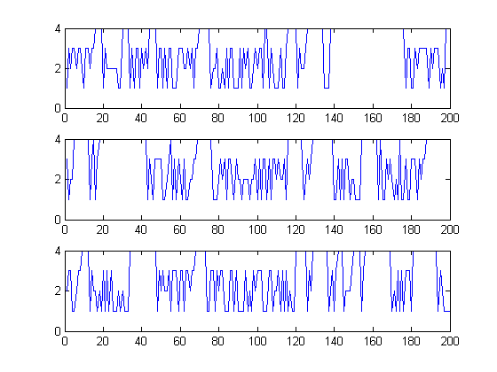

Prob. 1

1. Matlab code:

% for homework 1

% problem 2

clear; close all;

PI = [0.2 0.2 0.1 0.5; 0.1 0.3 0.4 0.2; 0.3 0.2 0.3 0.2; 0.1 0.3 0.1 0.5]; % transition matrix

%PI = [0.5 0.5 0 0; 0.1 0.9 0 0; 0 0 0.3 0.7; 0 0 0.2 0.8]; % transition matrix

%PI = [0 0.5 0 0.5; 0.5 0 0.5 0; 0 0.5 0 0.5; 0.5 0 0.5 0]; % transition matrix

M = 4; % number of chains

N = 4; % number of states

K = 1000; % number of time steps in each chain

for m = 1:M

x(1,m) = m; % random initial

for k = 2:K

% generate a chain

P = PI(x(k-1,m),:); %pick i-th row

U = rand;

if U < P(1)

x(k,m) = 1;

elseif (P(1)<U&&U<(P(1)+P(2)))

x(k,m) = 2;

elseif((P(1)+P(2))<U&&U<(P(1)+P(2)+P(3)))

x(k,m) = 3;

else

x(k,m) = N;

end

for n=1:N

p0(m,n,k) = sum(x(:,m)==n)/k;

end;

end

end

% Final Relative frequencies

for m = 1:M

for n = 1:N

p(m,n) = sum(x(:,m)==n);

end

end

p = p/K; % normalization

[V, D] = eig(PI');

ind = find(abs(diag(D)-1)< 1e-6);

P = V(:,ind)/sum(V(:,ind));

figure(1);

for m = 1:M

subplot(4,1,m);

plot(squeeze(p0(m,1,:)),'r');

hold on, plot(1:1000,P(1),'-.r')

hold on,plot(squeeze(p0(m,2,:)),'g');

hold on, plot(1:1000,P(2),'-.g')

hold on,plot(squeeze(p0(m,3,:)),'b');

hold on, plot(1:1000,P(3),'-.b')

hold on,plot(squeeze(p0(m,4,:)),'k');

hold on, plot(1:1000,P(4),'-.k')

ylim([0 1]);

end

The estimated relative frequencies for the 4 chains are:

p =

0.1520 0.2490 0.2500 0.3490

0.1460 0.2850 0.2170 0.3520

0.1560 0.2640 0.2430 0.3370

0.1470 0.2570 0.2380 0.3580

The true frequency of this Markov chain is:

P = 0.1607 0.2616 0.2231 0.3546

We could see that the estimated relative frequencies is very similar with the true frequency.

Problem 3:

The first transition matrix:

We get the true frequency is:

P = 0.0792 0.3961 0.1166 0.4081

With different initials, we get almost the same estimated frequencies like:

P1 =

0.1950 0.8050 0 0

0.1430 0.8570 0 0

0 0 0.2480 0.7520

0 0 0.2260 0.7740

P2 =

0.1970 0.8030 0 0

0.1460 0.8540 0 0

0 0 0.2280 0.7720

0 0 0.2070 0.7930

This means that the transition matrix do not have the stationary probability distributions. We also could observer this directly from the transition matrix , because this Markov Chain has states that could not be communicated.

The second transition matrix:

We get the true frequency is:

P = 0.2500 0.2500 0.2500 0.2500

With different initials, we get almost the same estimated frequencies like:

p 1=

0.2450 0.2440 0.2550 0.2560

0.2450 0.2600 0.2550 0.2400

0.2480 0.2460 0.2520 0.2540

0.2540 0.2610 0.2460 0.2390

p =

0.2490 0.2410 0.2510 0.2590

0.2610 0.2570 0.2390 0.2430

0.2510 0.2580 0.2490 0.2420

0.2540 0.2210 0.2460 0.2790

We could get almost the same estimated relative frequency with the true probabilities, which means that we could find the P such that it is a stationary Markov Chain.